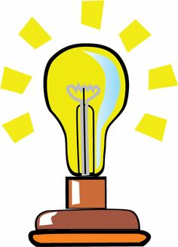
Describing Differences
We use ‘in contrast to’, ‘in comparison to’, ‘is different from’, ‘differs from’ and ‘unlike’ to explain differences between two things.
in contrast to differs from unlike different from in comparison to

1. Use the phrases in the box to complete these sentences:
a) In a physical change no new substance is formed ____________ a chemical change where a new substance is formed

b) Physical changes are often reversible _______________________ chemical changes that are never reversible.

c) Melting an ice cube is a physical change and _________________ burning paper that is a chemical change.

d) A colour change usually means a chemical change. Snow melting to water changes colour from white to clear and is definitely a physical change __________________________ an apple going brown as it rots which is a chemical change.

e) Exothermic chemical reactions give off energy, this is _________ ____________ endothermic chemical reactions that absorb energy.

f) A chemical change is usually detected by a range of things such as, colour change, gas given off or observing heat or light. This __________
_____________ a physical reaction that is usually detected by a change of shape, state or simple mixing.

